UNIVERSITY OF CALIFORNIA, LOS ANGELES
CS M117

Student name ___Jingtao Wang______
Modulation

Pre-laboratory Home Work # 1 (Due 04/06)
(HW and theoretical calculations in lab manual must be typed)

Section A
(T, Chapter 1; pg. 1-54)
Communication Networks

1. (2) What are two reasons for using layered protocols?
Reasons for using the layered protocols are (1) each layer is independent from other layers. We can work on one layer and don’t need to worry about the effect on the other layers. (2) It can simplify the network design process. Each layer is implemented with its own function and will only be brought together when needed. It is even easier to debug for this reason.

2. (2) What is the principal difference between connectionless communication and connection-oriented communication?
Connection has to be established in connection-oriented communication for data transfer while data transfer can be done at any time in connectionless communication.

3. Which of the OSI layers handles each of the following?
(a) (1) Dividing the transmitted bit stream into frames.
(b) (1) Determining which route through the subnet to use.

(a). Data link layer
(b). Network layer

4. (2) A system has an n-layer protocol hierarchy. Applications generate messages of length M bytes. At each of the layers, an h-byte header is added. What fraction of the network bandwidth is filled with headers?

With n layers each with h-byte of header, we have n*h bytes of header size. The total size is M+n*h bytes. The fraction of the network bandwidth filled with headers is therefore n*h/(M+n*h)
5. (2) List ways in which the OSI reference model and the TCP/IP reference model are the same, now list two ways in which they differ.

OSI reference modal and TCP/IP reference model are the same in the ways that (1) both of them are implemented based on a stack of protocols. (2) Both have application oriented protocols and transport oriented protocols with application oriented protocols at the above. (3) Both provide reliable transportation of data. However, they are also different from each other in that (1) TCP/IP offers both connection-oriented and connectionless communication whereas OSI only offers connection-oriented communication. (2) TCP/IP has an Internet layer while OSI doesn’t. OSI instead has a presentation layer, a physical layer and some other layers that a TCP/IP doesn’t have.
Section B
Amplitude Modulation and Frequency Modulation

A rectangular waveform signal has a value of +A for some continuous interval during the period (the “mark”), and has a value of -A for the remainder of the period (the “space”). The “duty cycle” d of the rectangular wave is defined as the length of the positive interval divided by the period.

1) The effective amplitude spectrum of a signal is built from the RMS voltages of each frequency represented in the Fourier series for that signal.

(a) (1) If the amplitude of square wave signal is A_{max} = 4V, and frequency is f ; draw the effective amplitude spectra (through the 8th harmonic) for functions.

(b) (1) If the amplitude of sinusoidal wave signal is A_{max} = 4V and frequency is f; draw the effective amplitude spectra.
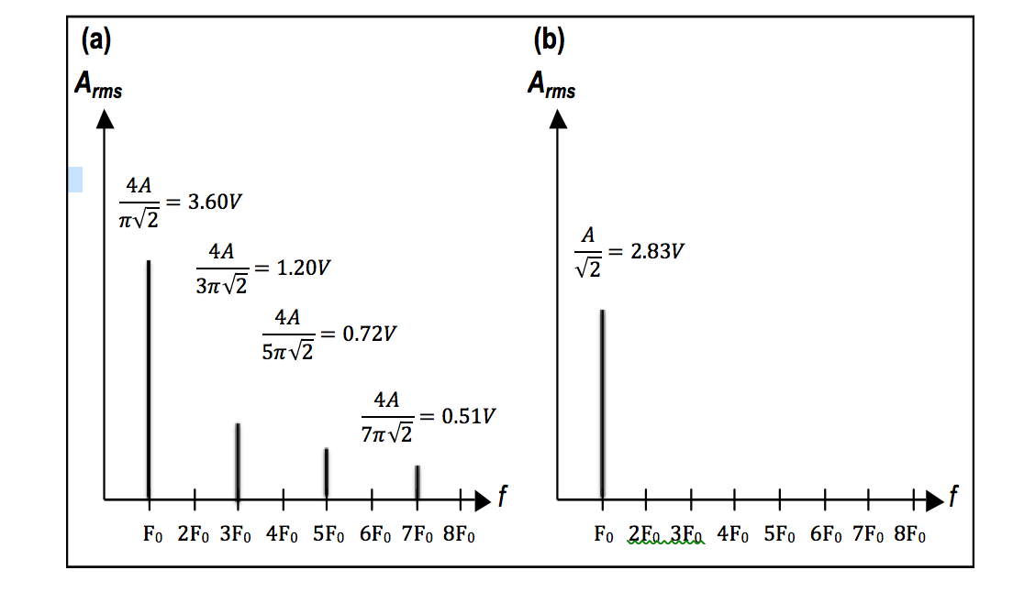

2). (2) The carrier signal S_{c} ( t ) = A_{c} cos( 2 f_{c} t ) is amplitude modulated by a baseband square wave signal S_{m} ( t ) with amplitude A_{m} = A_{c} (varies between +A_{c} and -A_{c} ) and frequency f_{m} . Write the Fourier series for the modulated signals S( t ), for DSBTC AM (where the baseband DC offset is equal to +A_{c} ) and DSBSC AM. Include the AM constructional coefficient K_{AM} .
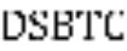
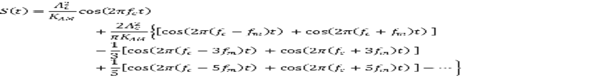
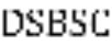

3) (1) Write the formula (using Bessel functions) for the frequency modulated signal when the baseband signal is S_{m} ( t ) = A_{m} sin( 2 f_{m} t ) and the carrier signal is:

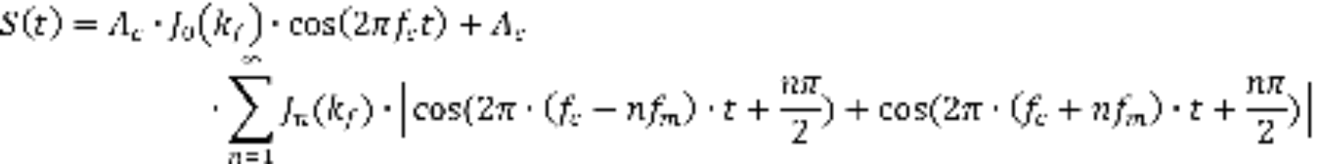

4) (2) Write the formula for the frequency modulation index k_{f} with baseband signal S_{m} ( t ) = A_{m} cos( 2 f_{m} t ), and calculate k_{f} when A_{m} = 4V, f_{m} = 1000 Hz and K_{FM} = 2 x 340.

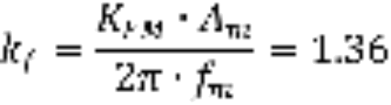

5) (2) Using the formula obtained in question (3) above and the Bessel function table given in the course reader, calculate and plot the power spectrum (amplitudes and frequencies) for the frequency modulated signal with a sinusoidal carrier signal (A_{c} = 4V and f_{c} = 25 kHz) and a sinusoidal baseband signal (A_{m} = 3V and f_{m} = 1000 Hz). Assume the generator has FM constructional coefficient K_{FM} = 2 x 340. Use these figures as the theoretical prediction in Part D of the experiment.
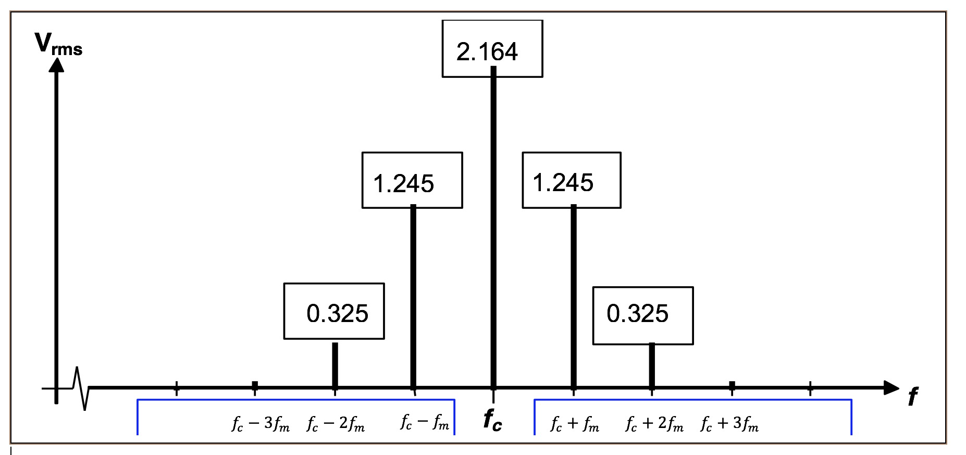

6) (1) What is a useful approximation for the bandwidth of an FM signal in terms of k_{f} and the bandwidth of the baseband signal?
